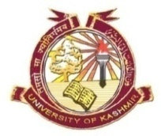
GRAMME IN BIORESOURCES
DEPARTMENT OF BOTANY
UNIVERSITY OF KASHMIR, SRINAGAR

Revised Date Sheet
It is notified for the information of all the concerned that the theory examination of Core and DCE courses M. Sc. 1st semester (Batch 2017) will be held as per the following schedule at Bioresources Block, University of Kashmir Srinagar.
Venue: Bioresources Block
Time: 11:00am
10.30 (Friday)

M. Sc 1st Semester
Course Code | Course Title | Date | Day
BR15101CR | Biodiversity and Bioresources | 14-12-2017 | Thursday
BR1102CR | Plant Resources | 18-12-2017 | Monday
BR15103CR | Animal Resources | 22-12-2017 | Friday
BR15104DCE | Cellular and Molecular Biology | 26-12-2017 | Tuesday
BR15105DCE | Basic and applied Immunology | 30-12-2017 | Saturday

Coordinator Bioresources

No. F(Datesheet-M.Sc 1st Sem)Biores/KU/17
Date: 07-12-2017

